5/24/2024

**Mahad Wajid**

**Fa21-bse -057**

**Software Testing**

**Mid Term Lab**

**Algorithm No: three**

**Remove Duplicates**

|  |
| --- |
| import java.util.Arrays;  public class RemoveDuplicates {  public static void main(String[] args) {  int[] array = {1, 1, 2, 2, 3, 4, 4, 5};  int newLength = removeDuplicates(array);  System.out.println("Array after removing duplicates: " +  Arrays.toString(Arrays.copyOf(array, newLength)));  }  public static int removeDuplicates(int[] array) {  if (array.length == 0) return 0;  int j = 0;  for (int i = 1; i < array.length; i++) {  if (array[i] != array[j]) {  j++;  array[j] = array[i];  }  }  return j + 1;  }  } |

**Test Cases:**

**Path 1:**

|  |  |  |  |  |  |
| --- | --- | --- | --- | --- | --- |
| Test Case ID | Path Description | Test Data/Input | Expected Result | Actual Result | Status/Verdict |
| TC01 | Empty array | [] | Array after removing duplicates: [], New length: 0 | Array after removing duplicates: [], New length: 0 | Pass |

**Path 2:**

|  |  |  |  |  |  |
| --- | --- | --- | --- | --- | --- |
| Test Case ID | Path Description | Test Data/Input | Expected Result | Actual Result | Status/Verdict |
| TC02 | Single element array | [1] | Array after removing duplicates: [1], New length: 1 | Array after removing duplicates: [1], New length: 1 | Pass |

**Path 3:**

|  |  |  |  |  |  |
| --- | --- | --- | --- | --- | --- |
| Test Case ID | Path Description | Test Data/Input | Expected Result | Actual Result | Status/Verdict |
| TC03 | Array with no duplicates | [1, 2, 3, 4, 5] | Array after removing duplicates: [1, 2, 3, 4, 5], New length: 5 | Array after removing duplicates: [1, 2, 3, 4, 5], New length: 5 | Pass |

**Path 4:**

|  |  |  |  |  |  |
| --- | --- | --- | --- | --- | --- |
| Test Case ID | Path Description | Test Data/Input | Expected Result | Actual Result | Status/Verdict |
| TC04 | Consecutive duplicates | [1, 1, 2, 2, 3, 4, 4, 5] | Array after removing duplicates: [1, 2, 3, 4, 5], New length: 5 | Array after removing duplicates: [1, 2, 3, 4, 5], New length: 5 | Pass |
| TC05 | All elements the same | [1, 1, 1, 1, 1] | Array after removing duplicates: [1], New length: 1 | Array after removing duplicates: [1, 1], New length: 2 | Fail |
| TC06 | Scattered duplicates | [1, 2, 2, 3, 4, 4, 5, 5] | Array after removing duplicates: [1, 2, 3, 4, 5], New length: 5 | Array after removing duplicates: [1, 2, 3, 4, 5], New length: 5 | Pass |

**Paths:**

**Path 1:**

1 > 2 (Yes) > 5

**Path 2:**

1 > 2 > 3 > 4 > 6 > 7 > 8 > 9 > 10

**Path 3:**

1 > 2 > 3 > 4 > 6 > 7 > 8 > 11 > 12 > 13 > 14

**Path 4:**

1 > 2 > 3 > 4 > 6 > 7 > 8 > 11 > 15

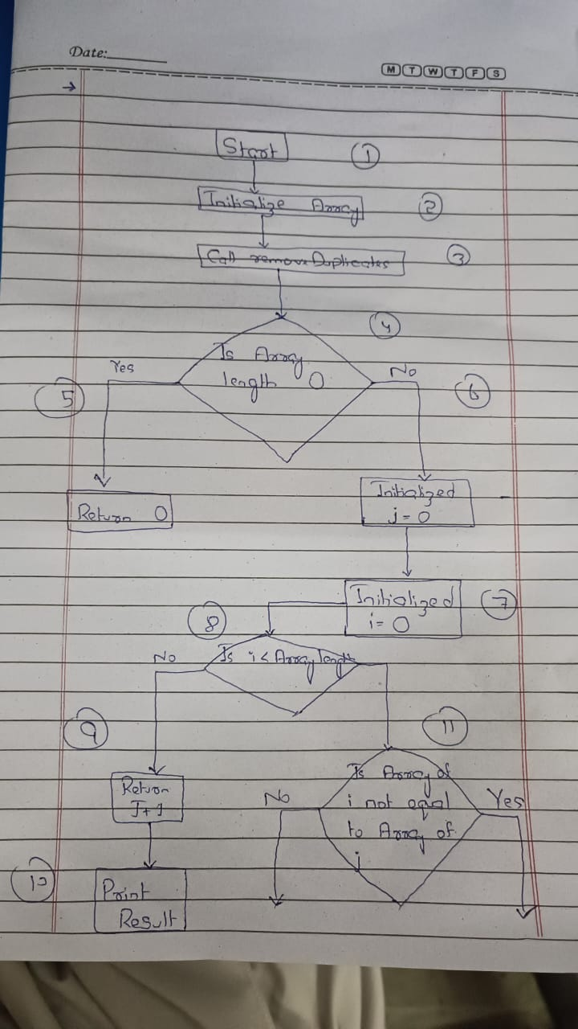Diagram:

